**Scratch Assay Protocol**

1. 2 parallel lines are drawn with a pencil under the 6-well plate.
2. Cells are seeded to a 6-well plate as to be confluent the next day.

(EGF treatment in 3.günü scratch atıp kontrol etmek için T24 control 200k;EGF 350k 5637 control 300k; EGF 400k olacak şekilde ekim yapıldı. Sayılar az geldi ertesi gün scratch atıldı.)

1. When cells are confluent, scrape the cell layer -gently- from top to bottom in a straight line using a 200ul tip. (çizgileri düzgün ve net çekmek önemli.)
2. Wash the cells gently with 1x PBS two times.
3. Add cell medium with 2% FBS into wells.
4. Image the cells using phase contrast microscopy and take photos for “Time=0” on 10x magnification.
5. Incubate the cells in the incubator.
6. Take photos for different time points (12h, 24h…) until cells migrate to the middle of the scratch.

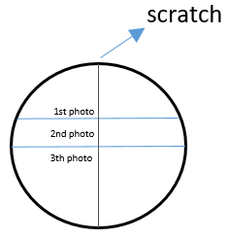 x3 rep 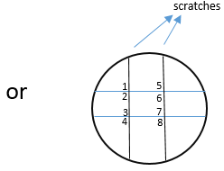 x2 rep

Analysis:

1. Download ImageJ.
2. Download Wound_healing_size_tool.jim
3. Open scratch assay image with ImageJ.
4. Plugins → Macros → Run → Toolsets → Wound_healing_size_tool.jim
5. Select “Wound Healing Size Tool”
6. Click the image.
7. Click the Ok. *If the scratch window is not correct, change the “variance window radius” 20 to 10 etc.*
8. Use “Area Inches” value for the analysis.
9. Calculate wound healing percentages by calculating the other hours relatively, with 0h being 100. The formula is 0h=100-(0h*100/0h) , 24h=100-(24h*100/0h) etc.
10. Visualize results with the bar graph.

**Tips:**

* Scratch atmadan bir gün önce hücrelere %2 FBS’li medium verirsek standard sapma azalıyor.
* Area inches 0. Saatte 400 üzerindeyse scratch çok geniş demek bu değerleri analize dahil etme.
* Analiz yaparken 0.saatteki tüm area inch değerlerini alt alta koyarak sapanları at.